**MINISTRY OF EDUCATION AND TRAINING**

**FPT UNIVERSITY**

Capstone Project Document

**Job Searching System**

|  |  |
| --- | --- |
| **Group JSS** | |
| **Group members** | Huỳnh Đức Tài – Leader – SE60630  Nguyễn Ngọc Thiện – Member – SE90129  Phạm Quốc Thái – Member – SE60599  Võ Hoàn Thiện – Member – SE60788  Trịnh Văn Hoàng – Member – 01769  Trần Chung Thành – Member – 01611 |
| **Supervisor** | Mr. Trần Đình Trí |
| **Ext. Supervisor** | N/A |
| **Project code** | JSS |

-Hanoi, 05/2015-

# Table of Contents

# Definition, Acronyms and Abbreviations

|  |  |
| --- | --- |
| **Name** | **Definition** |
| JSS | Job Searching System |
| App | Application |
| OS | Operating System |
| Admin | Administrator |
| Mod | Moderator |
| API | Application Programming Interface |
| HTTP | Hyper Text Transfer Protocol |

# 4. System Design Description (SDD)

## 4.1. Design Overview

This document describes the technical and user interface design of JSS system. It includes the architectural design, the detailed design of common functions and business functions. It also includes the design of database model, and overall design of user interface.

The architectural design describes the overall architecture of the system and the architecture of each main component and subsystem. It will describe the patterns being used, the role of each component and the role of the system in the working environment.

The detailed design describes static and dynamic structure for each component and functions. It includes class diagrams, class explanations and sequence diagrams of the main use cases.

The database design describes the relationships between entities and details of each entity. It uses notations of MySQL as it is the database server for developing the system.

The user interface design describes the layout of the system, and some design for the screens.

## 4.2. System Architectural Design

### 4.2.1. Choice of System Architecture

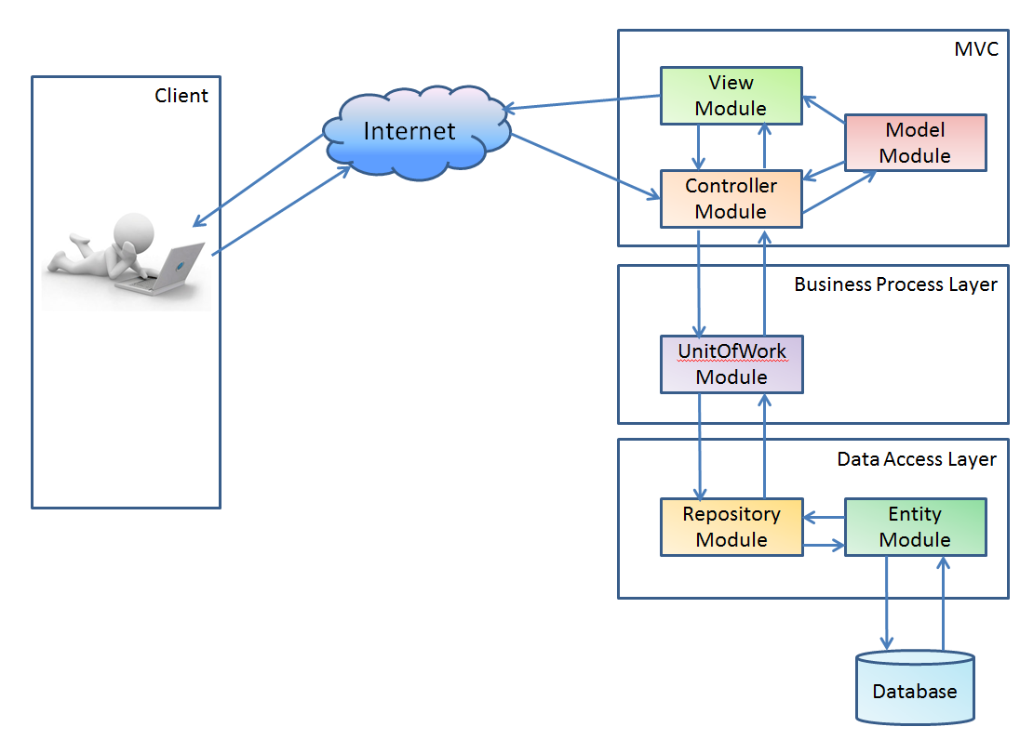

Figure 4. 1: Architecture diagram

The system realize heavily on Client-Server as the main architecture and MVC pattern to deliver services to its users. Data will be transfer through the internet using some common protocols.

### 4.2.2. Discussion of Alternative Designs

### 4.2.3. Description of System Interface

The main entities of the above diagram will be described as following:

* **Clients:** These include internet browsers running on personal computers, or mobile applications. The web browsers will interact with the web application via normal protocols (HTTP, HTTPS…).
* **Server:** The server of the system running on web server. It includes main components Web application. Web application is responsible for creating web pages. This will be developed in ASP.NET Web platform using ASP.NET MVC 5 framework.
* **Entity and Repository:** The data access will accept data before request to the Database and response to the System.
* **UnitOfWork:** The business process will do group of data access function.
* **Database:** This is the central data storage for the system. It may be running on a separate server to the Server, or in the same machine. JSS database will use SQL Server 2008 in order to utilize the features provided by Microsoft.NET framework.

The Model-View-Controller (MVC) pattern separates the modeling of the domain, the presentation, and the actions based on user input into three separate classes:

**Model:** The model manages the behaviors and data of the application domain, responds to requests for information about its state (usually from the view), and responds to instruction to change state (usually from the controller).

**View:** The view manages the display of information.

**Controller:** The controller interprets the mouse and keyboard inputs from the user, informing the model and/or the view to change as appropriate.

## 4.3. Component Diagram

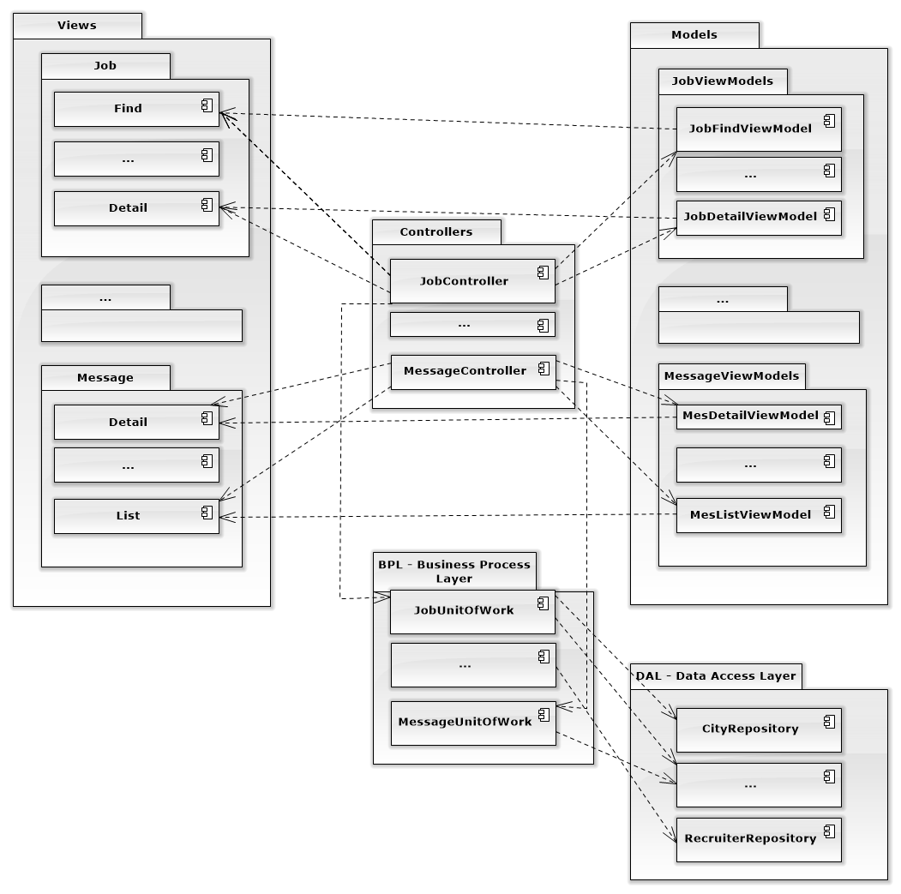

Figure 4. 2 – Component Diagram

## 4.4. Detailed Description of Components

### 4.4.1. Controllers

#### 4.4.1.1.Class Diagram

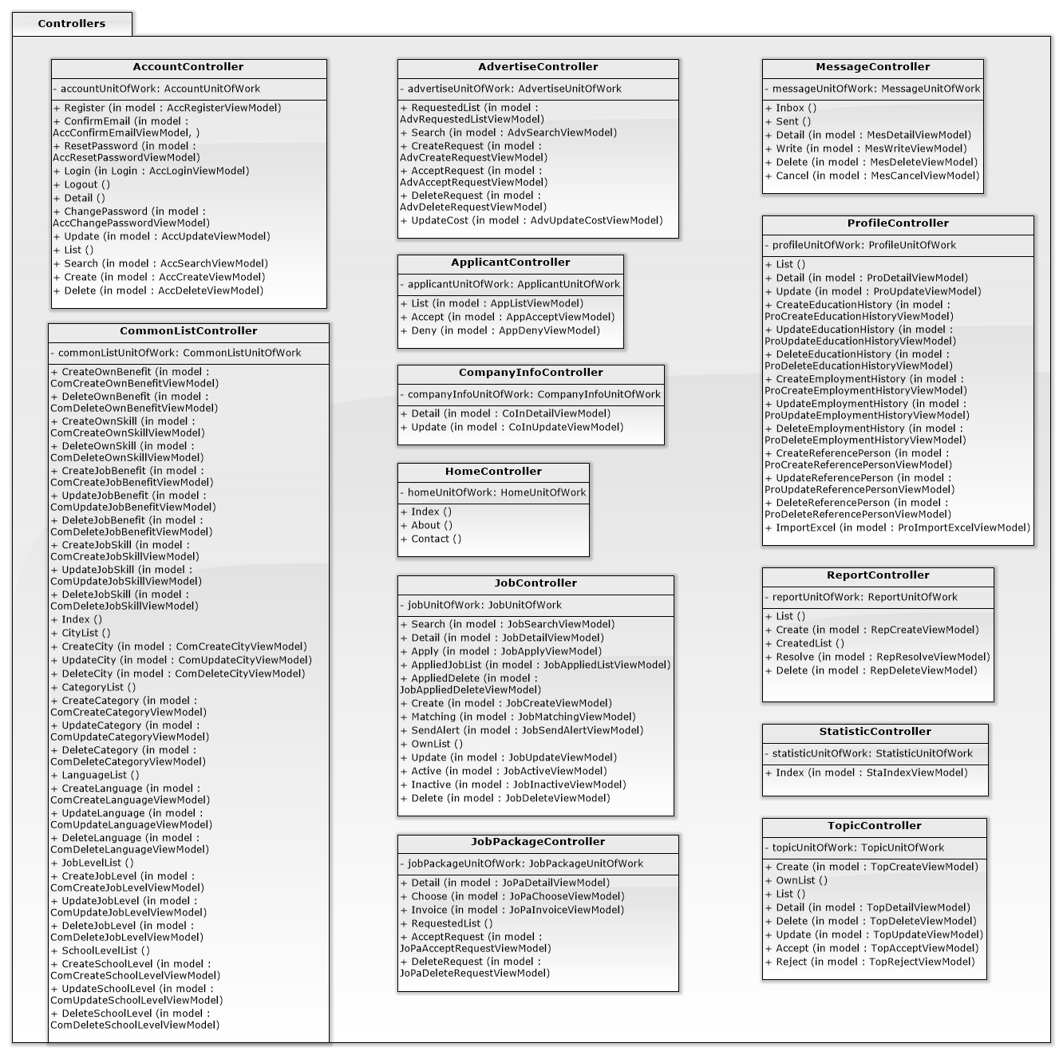

Figure 4. 3 – Controller Class Diagram

#### 4.4.1.2.Class Diagram Explanation

#### 4.4.1.3.Algorithms of important methods in each class, specified in pseudo code or by Flow-Chart

### 4.4.2. Models

#### 4.4.2.1.Class Diagram

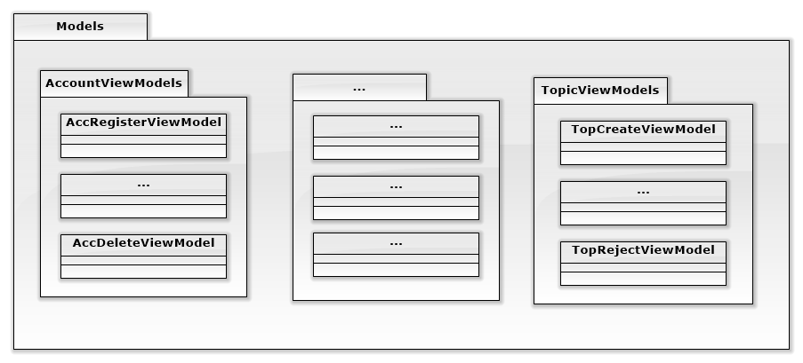

Figure 4. 4 – Model Class Diagram

#### 4.4.2.2.Class Diagram Explanation

All Model Class are used by corresponding Controller, we can refer to Controller Class Diagram.

#### 4.4.2.3.Algorithms of important methods in each class, specified in pseudo code or by Flow-Chart

### 4.4.3. Views

#### 4.4.3.1.Class Diagram

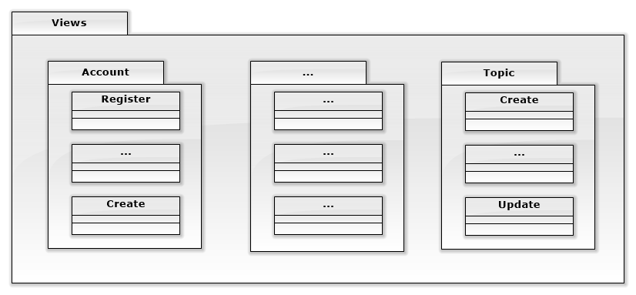

Figure 4. 5 – View Class Diagram

#### 4.4.3.2.Class Diagram Explanation

All View Class are used by corresponding Controller, we can refer to Controller Class Diagram.

#### 4.4.3.3.Algorithms of important methods in each class, specified in pseudo code or by Flow-Chart

### 4.4.4. DAL – Data Access Layer

#### 4.4.4.1.Class Diagram

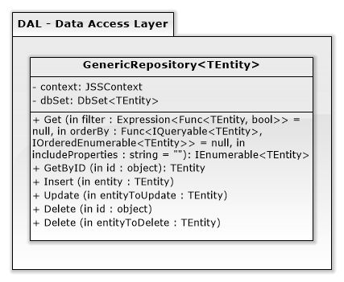

Figure 4. 6 – DAL Class Diagram

#### 4.4.4.2.Class Diagram Explanation

One GenericRepository class can handle every single table in database. This class can be create a large number of instance in UnitOfWork.

#### 4.4.4.3.Algorithms of important methods in each class, specified in pseudo code or by Flow-Chart

### 4.4.5. BPL – Business Process Layer

#### 4.4.5.1.Class Diagram

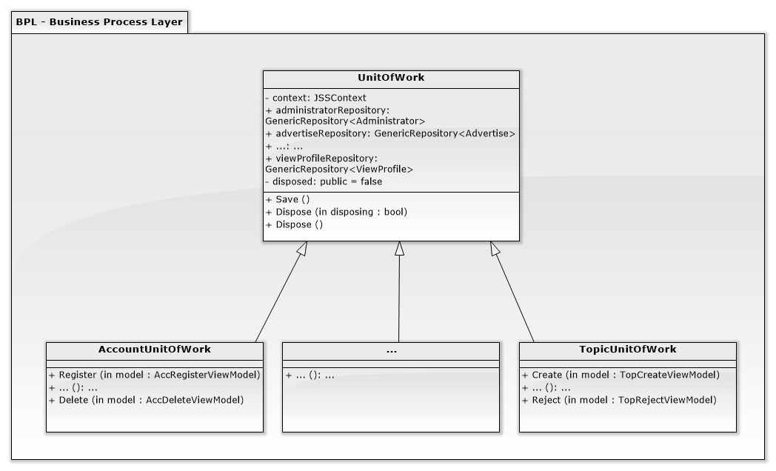

Figure 4. 7 – BPL Class Diagram

#### 4.4.5.2.Class Diagram Explanation

One UnitOfWork will be created to provide each of Controller. Therefore, we can refer to Controller Class Diagram.

#### 4.4.5.3.Algorithms of important methods in each class, specified in pseudo code or by Flow-Chart

## 4.5. Sequence Diagram

## 4.6. User Interface Design

### 4.6.1 HomeController

#### 4.6.1.1 Index

Figure 4. 8 - Index

### 4.6.2 AccountController

#### 4.6.2.1 Login

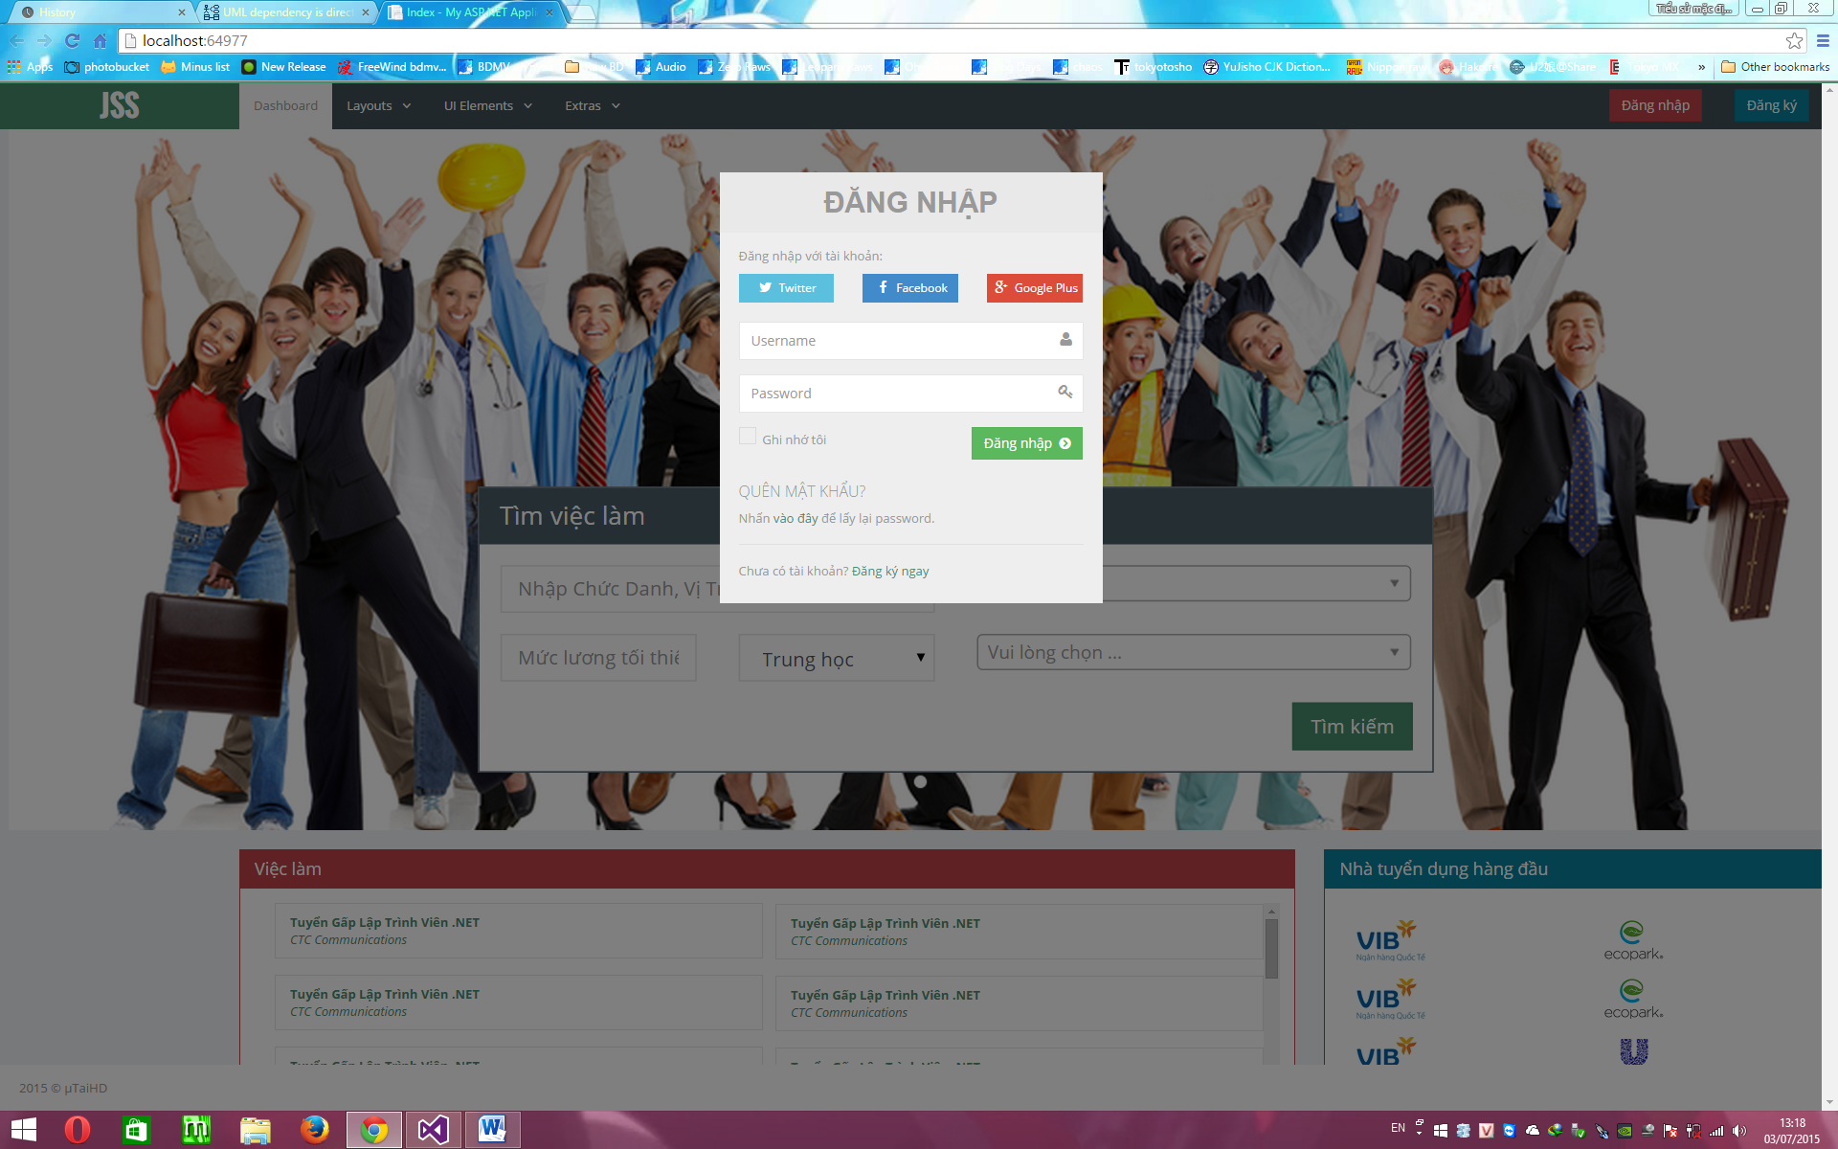

Figure 4. 9 - Login

### 4.6.3 ApplicantController

#### 4.6.3.1 List

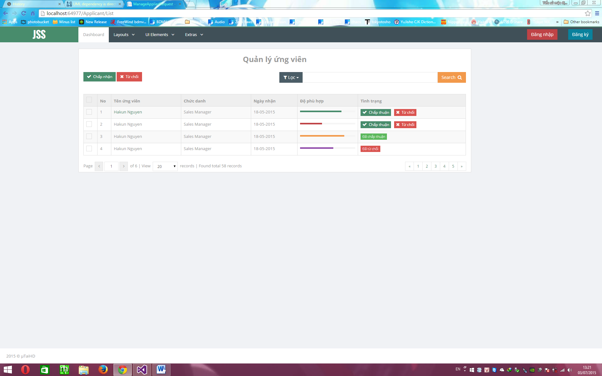

Figure 4. 10 - List

### 4.6.4 JobController

#### 4.6.4.1 Find

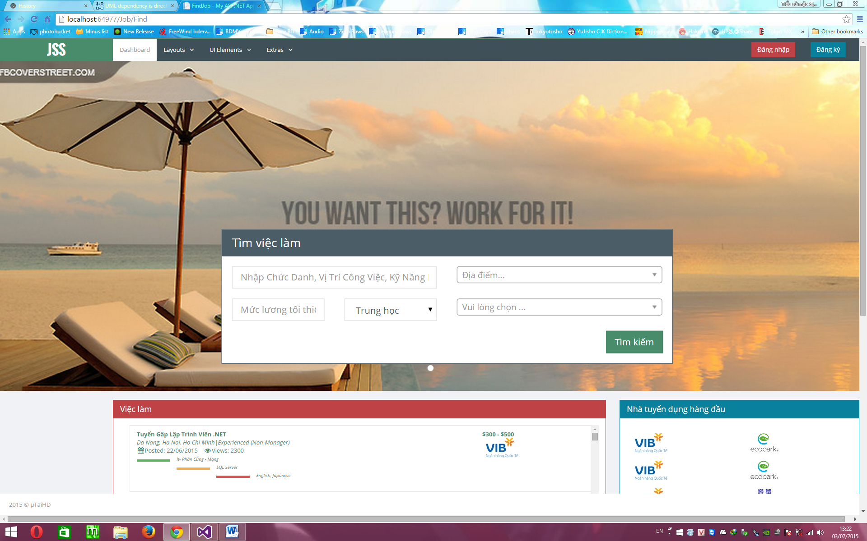

Figure 4. 11 - Find

#### 4.6.4.2 Create

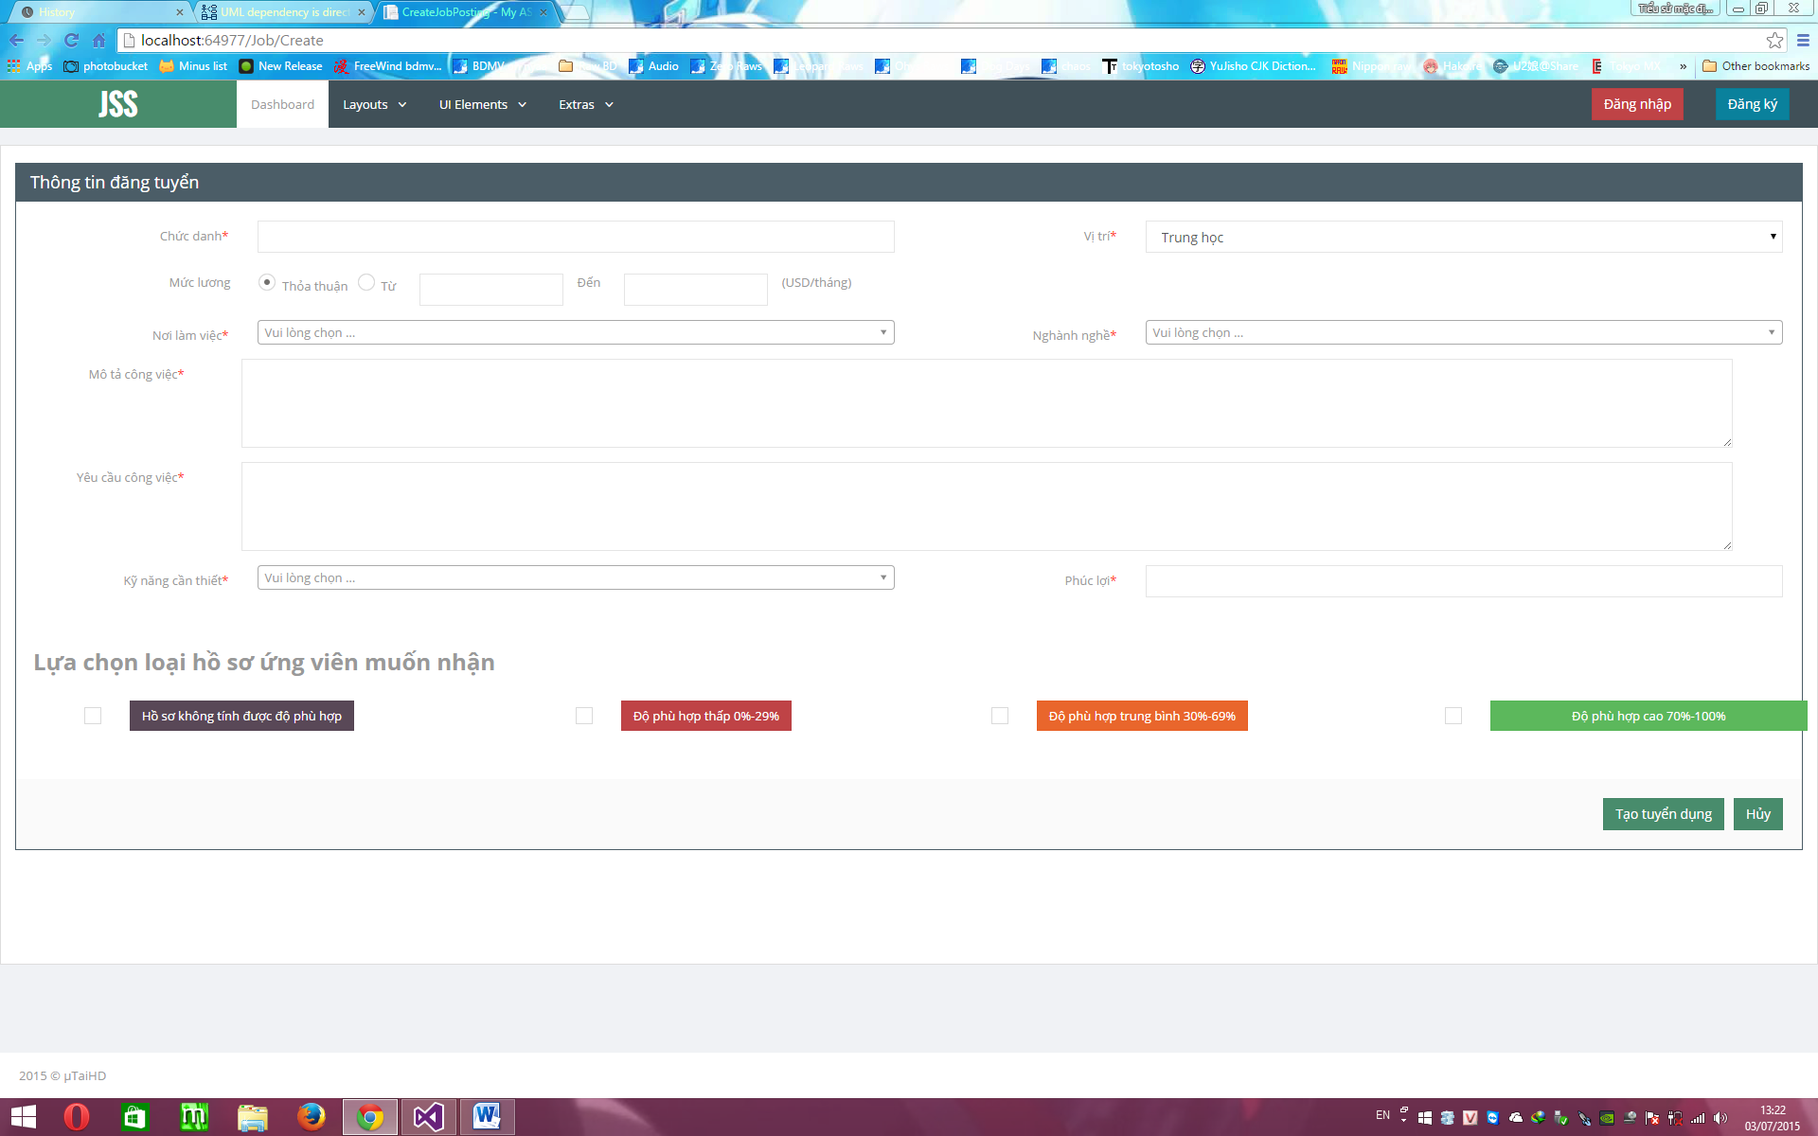

Figure 4. 12 - Create

#### 4.6.4.3 Detail

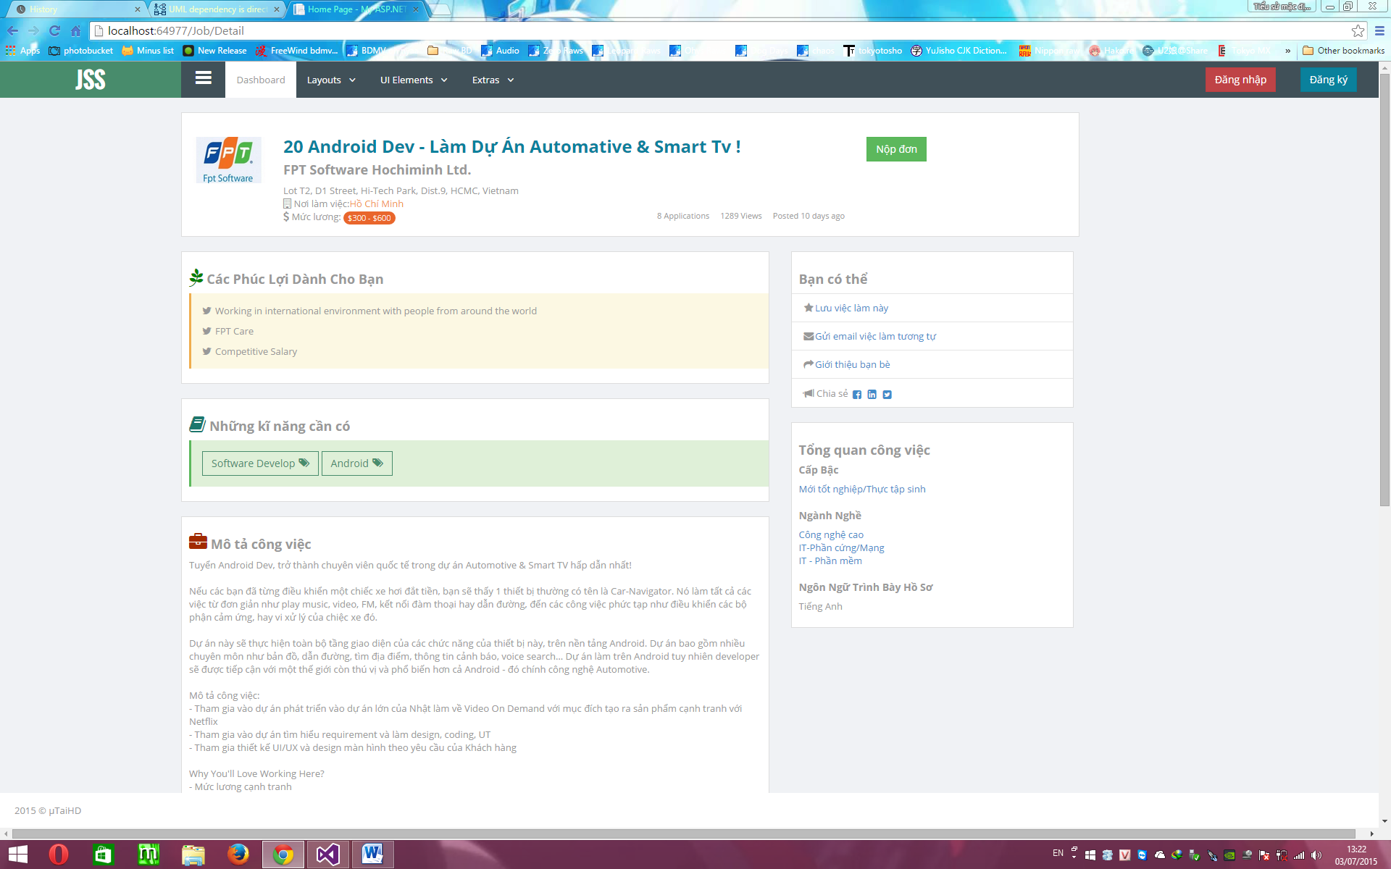

Figure 4. 13 - Detail

#### 4.6.4.4 OwnList

Figure 4. 14 - OwnList

#### 4.6.4.5 AppliedJobList

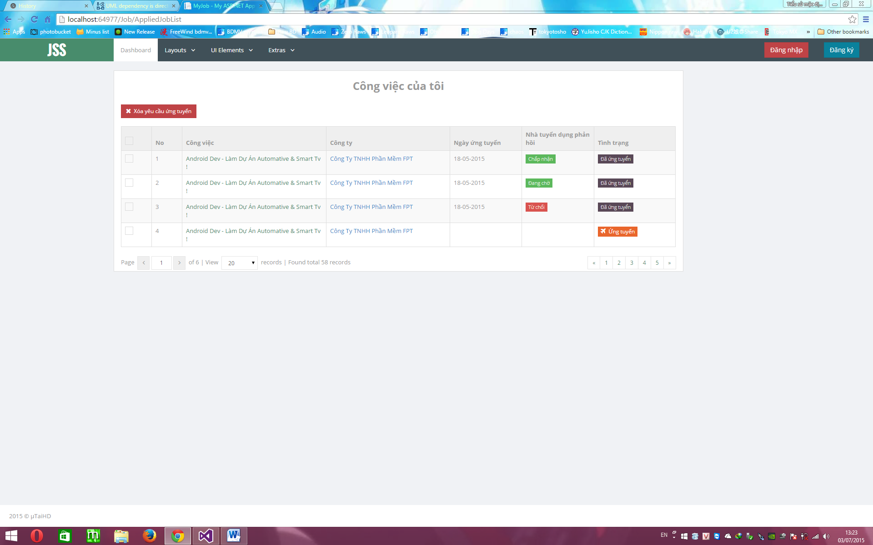

Figure 4. 15 - AppliedJobList

### 4.6.5 JobPackageController

#### 4.6.5.1 Choose

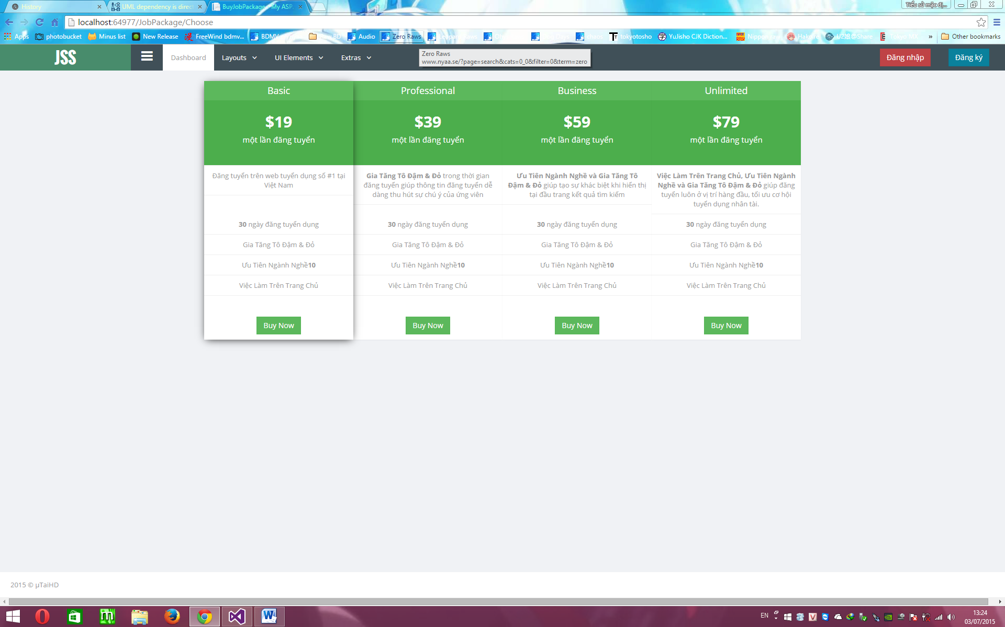

Figure 4. 16 - Choose

#### 4.6.5.2 Invoice

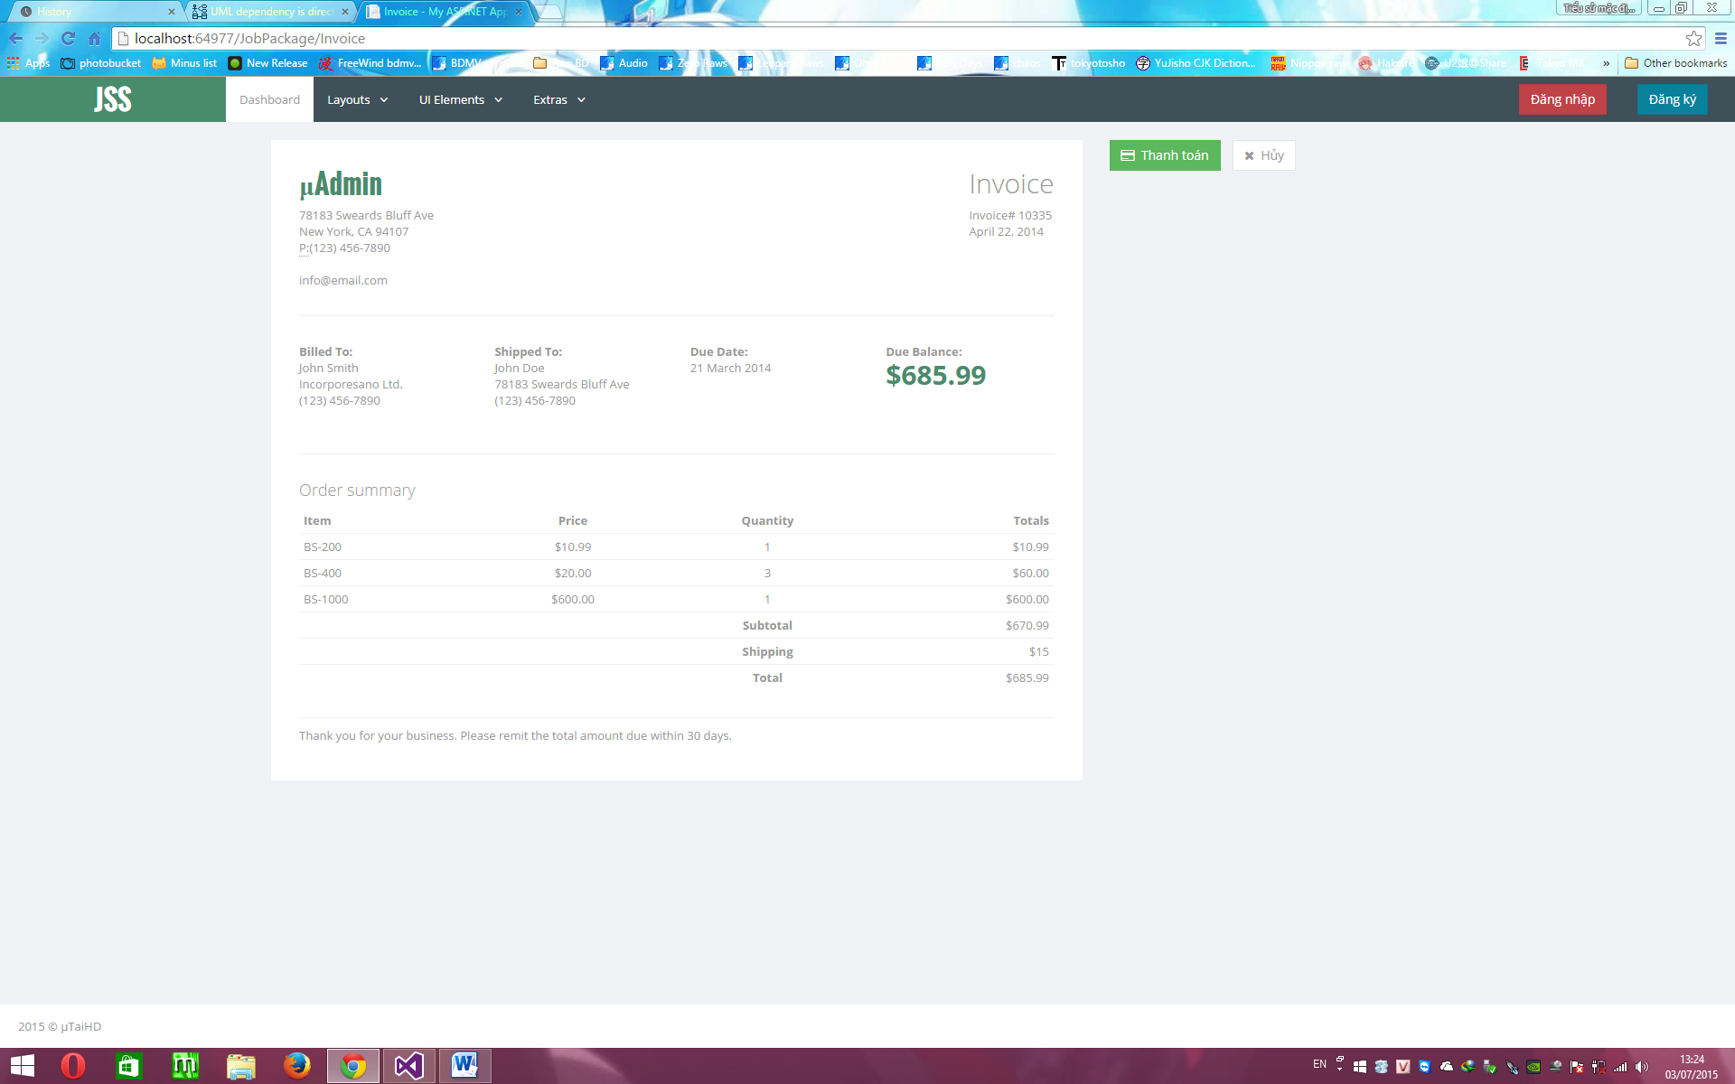

Figure 4. 17 - Invoice

### 4.6.6 MessageController

#### 4.6.6.1 Inbox

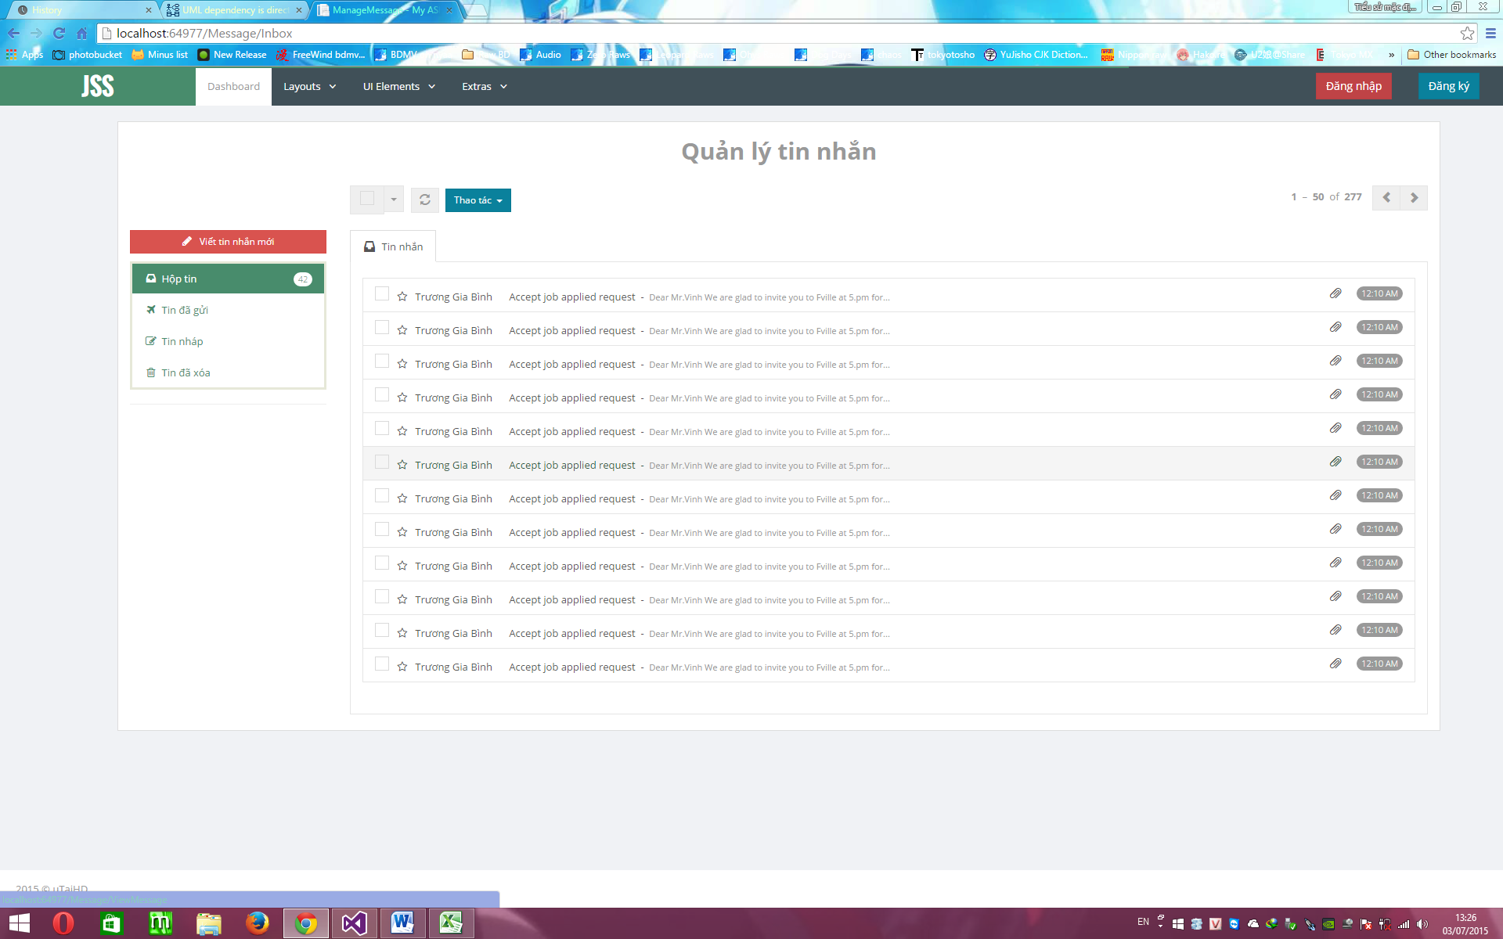

Figure 4. 18 - Inbox

#### 4.6.6.2 Detail

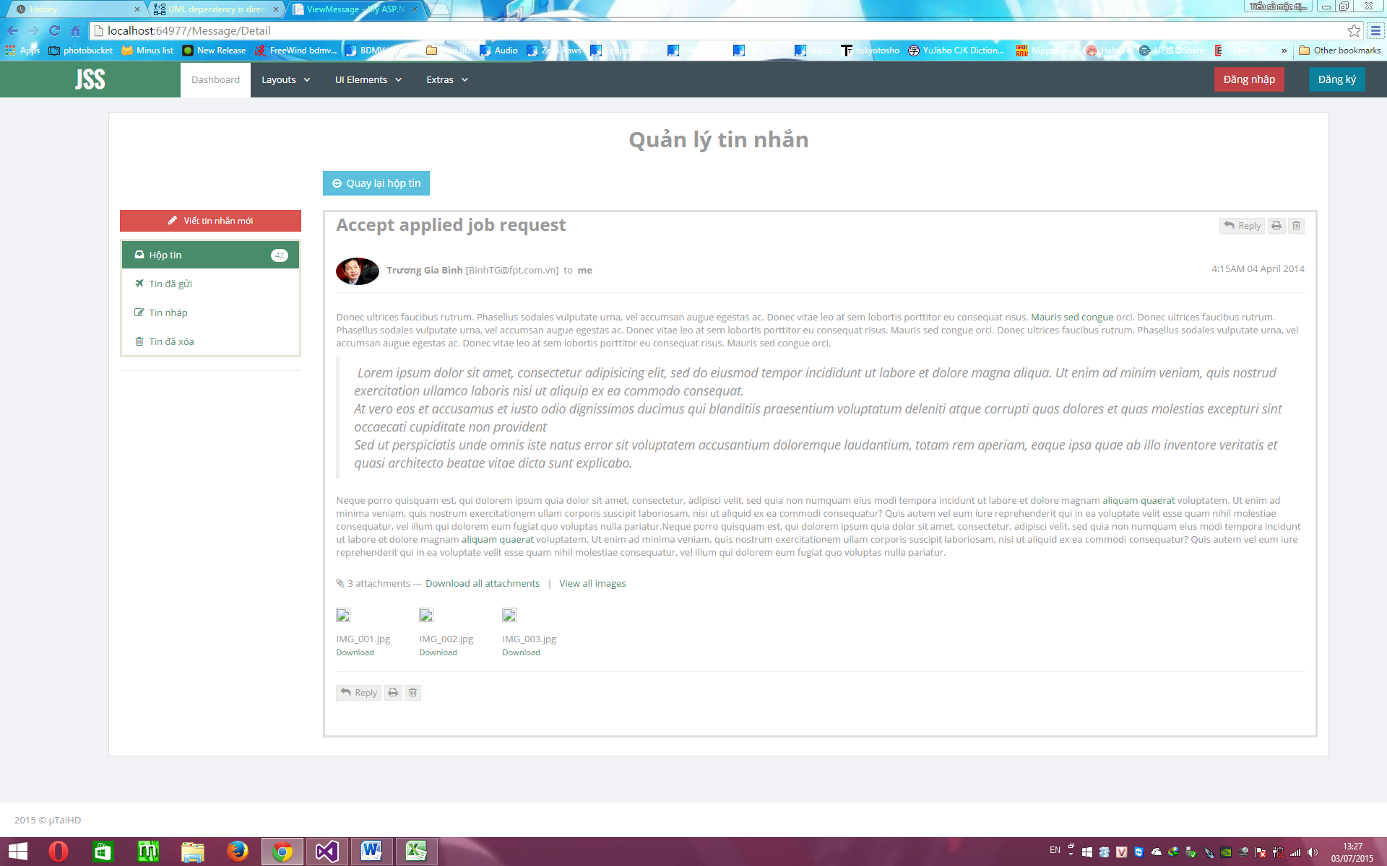

Figure 4. 19 - Detail

### 4.6.7 ProfileController

#### 4.6.7.1 List

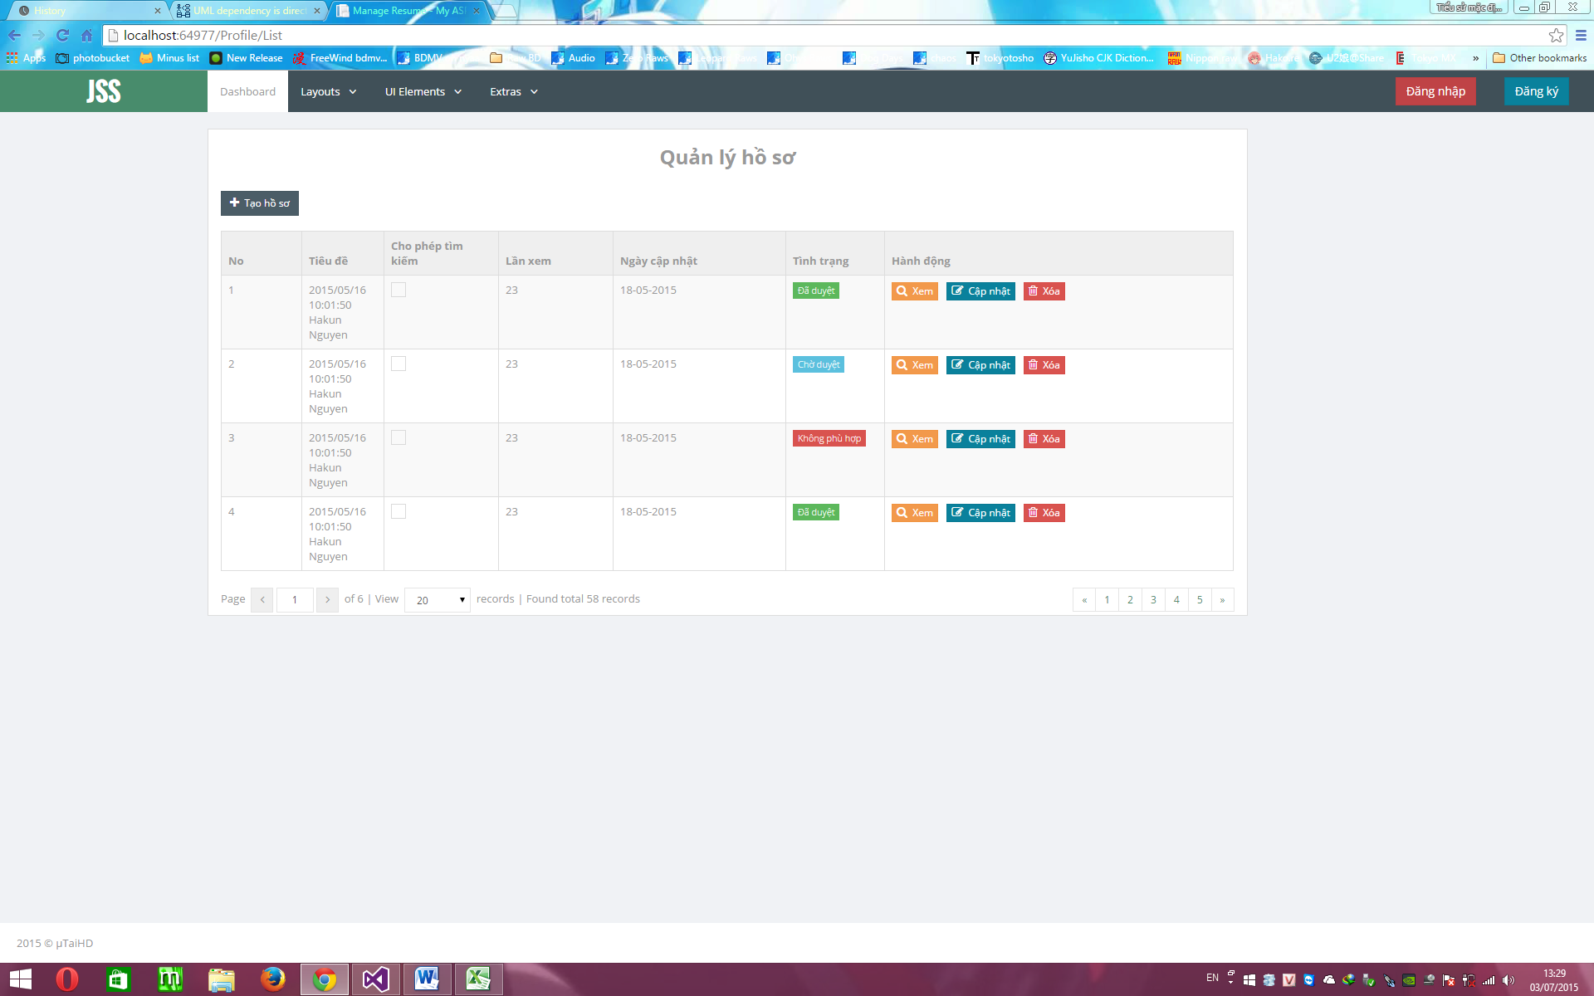

Figure 4. 20 - List

#### 4.6.7.2 Create

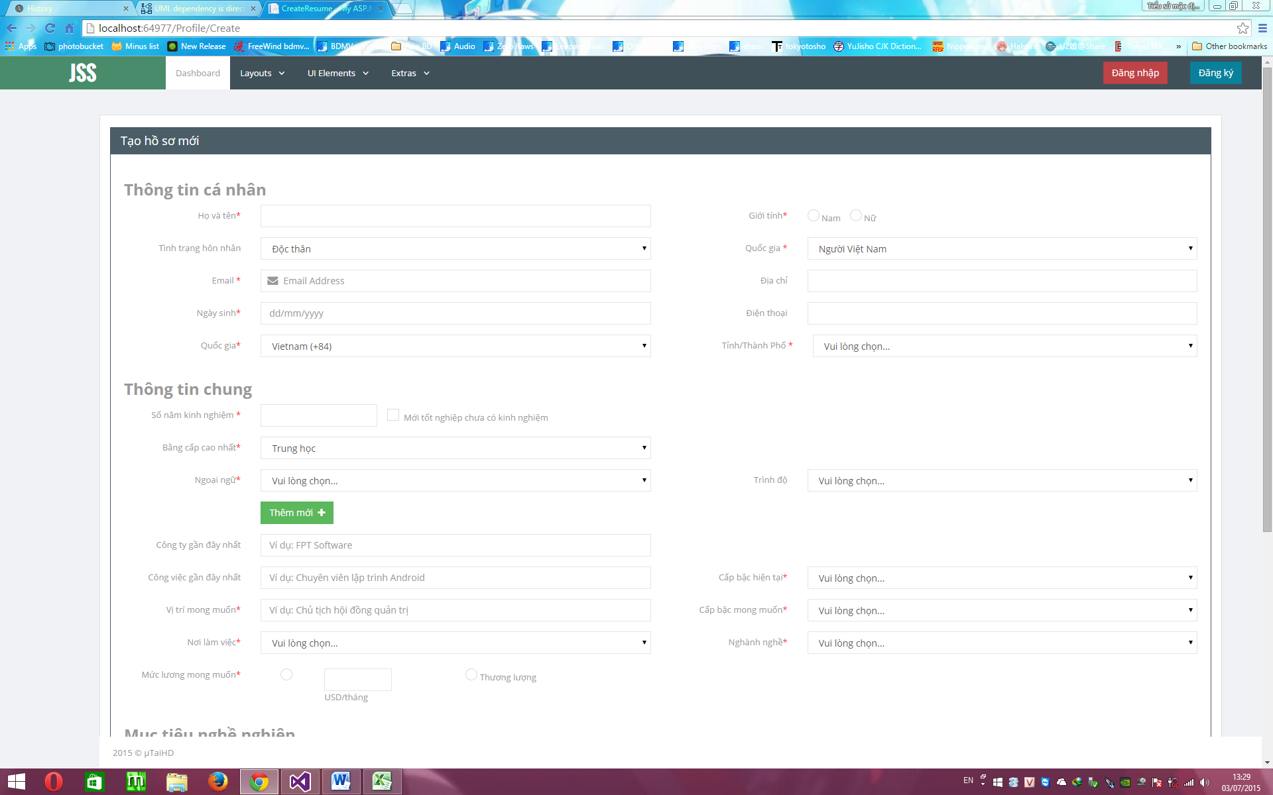

Figure 4. 21 - Create

### 4.6.8 TopicController

#### 4.6.8.1 List

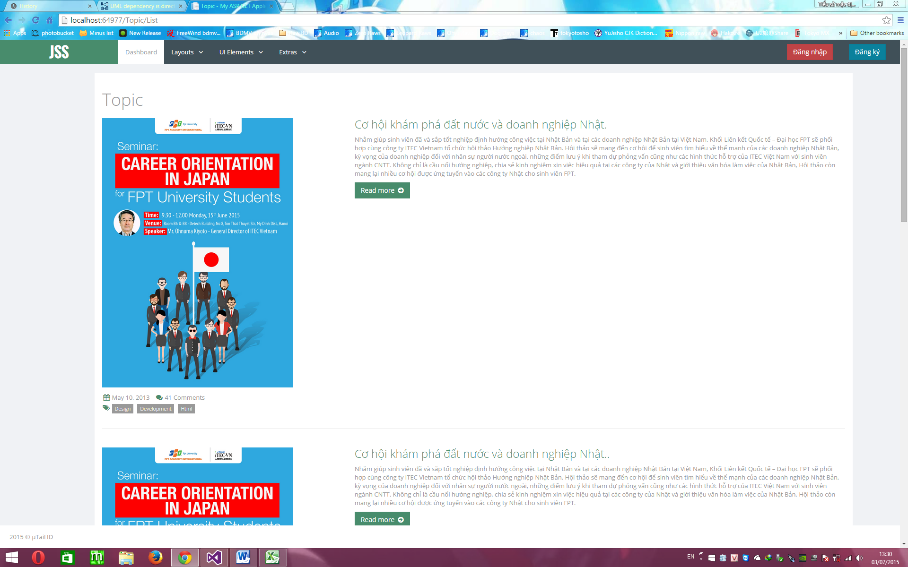

Figure 4. 22 - List

#### 4.6.8.2 Create

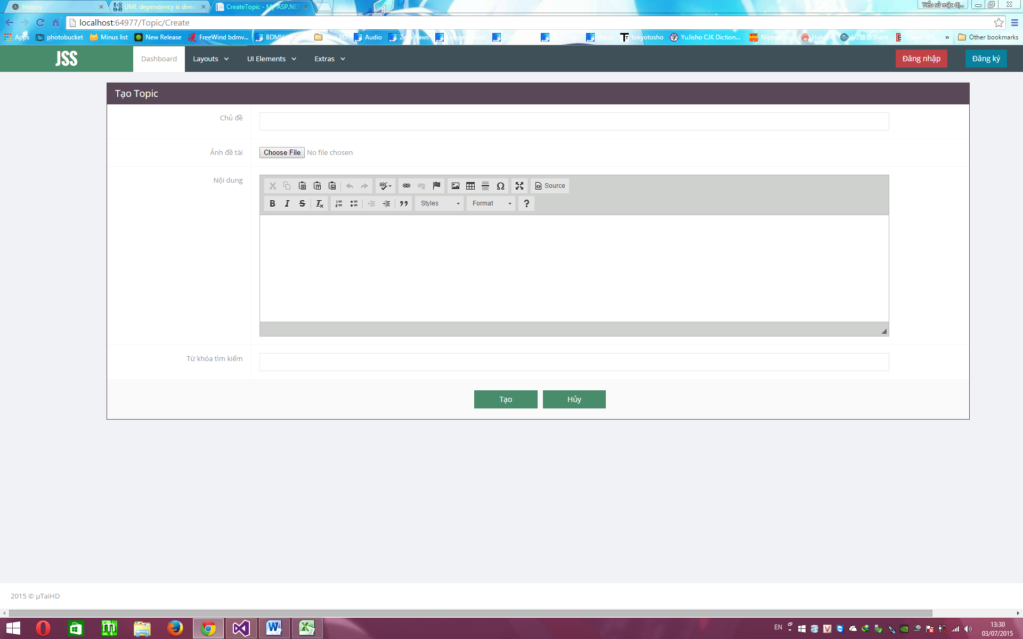

Figure 4. 23 - Create

#### 4.6.8.3 Detail

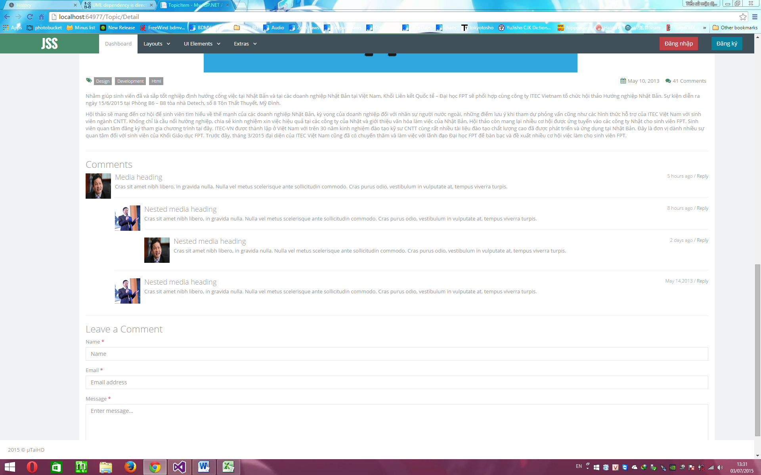

Figure 4. 24 - Detail

## 4.7. Database Design

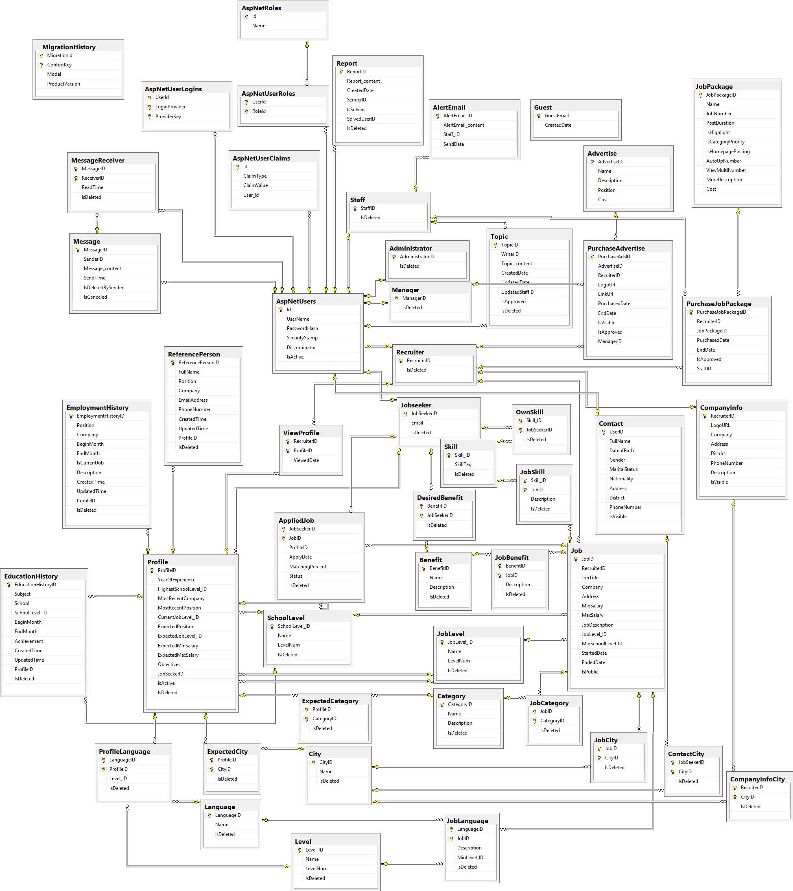

Figure 4. 25 – Database Diagram